Updated: 5 August 2014

General Knowledge for Test and Inspections

General Orders (For Marines & Marine Options):
- To take charge of this post and all government property in view.
- To walk my post in a military manner, keeping always on the alert and observing everything that takes place within sight or hearing.
- To report all violation of orders I am instructed to enforce.
- To repeat all calls from posts more distant from the guard house than my own.
- To quit my post only when properly relieved.
- To receive, obey, and pass on to the sentry who relieves me, all orders from commanding officer, officer of the day, and all officers and noncommissioned officers of the guard only.
- To talk to no one except in the line of duty.
- To give the alarm in case of fire or disorder.
- To call the corporal of the guard in any case not covered by instructions.
- To salute all officers, and all colors and standards not cased.
- To be especially watchful at night, and during the time for challenging, to challenge all persons on or near my post and to allow no one to pass without proper authority.

Code of Conduct
Developed after and in response to the Korean War, the Code of Conduct was first promulgated by President Eisenhower in 1955. The Code was reaffirmed in 1964, in DOD Directive No. 1300.7. In 1977, President Carter amended Article V of the Code. The Code, although first expressed in written form in 1955, is based on time-honored concepts and traditions that date back to the days of the American Revolution.

ARTICLE I
I am an American, fighting in the forces which guard my country and our way of life. I am prepared to give my life in their defense.

ARTICLE II
I will never surrender of my own free will. If in command, I will never surrender the members of my command while they still have the means to resist.

ARTICLE III
If I am captured I will continue to resist by all means available. I will make every effort to escape and aid others to escape. I will accept neither parole nor special favors from the enemy.

ARTICLE IV
If I become a prisoner of war, I will keep faith with my fellow prisoners. I will give no information or take part in any actions which might be harmful to my comrades. If I am senior, I will take command. If not, I will obey the lawful orders of those appointed over me and will back them up in every way.

ARTICLE V
When questioned, should I become a prisoner of war, I am required to give name, rank, service number, and date of birth. I will evade answering further questions to the utmost of my ability. I will make no oral or written statements disloyal to my country and its allies or harmful to their cause.

ARTICLE VI
I will never forget that I am an American, fighting for freedom, responsible for my actions, and dedicated to the principles which made my country free. I will trust in my God and in the United States of America.

MAJOR PUNITIVE Articles of the UCMJ
ARTICLE 85: Desertion
ARTICLE 86: Absent without leave
ARTICLE 89: Disrespect towards a superior commissioned officer
ARTICLE 90: Assault on or willfully disobeying a superior commissioned officer
ARTICLE 91: Insubordinate conduct toward a warrant officer, noncommissioned officer, or petty officer
ARTICLE 92: Failure to obey order or regulation
ARTICLE 94: Mutiny or sedition
ARTICLE 114: Dueling
ARTICLE 121: Larceny and wrongful appropriation
ARTICLE 128: Assault
ARTICLE 134: General Article: You cause or are involved in any disorder or show neglect to the prejudice of good order discipline in the armed forces, you demonstrate any conduct of a nature to bring discredit upon the armed forces, You commit any crime and offense that is not capital.

TYPES OF DISCHARGES
- Honorable
- General
- Bad Conduct
- Dishonorable

Core Values of the United States Navy and Marine Corps

Honor, Courage, and Commitment
Make sure they guide your performance, behavior, and conduct.
Honor: I am accountable for my professional and personal behavior. I will be mindful of the privilege I have to serve my fellow Americans.
Courage: Courage is the value that gives me the moral and mental strength to do what is right, with confidence and resolution, even in the face of temptation or adversity.
Commitment: The day-to-day duty of every man and woman in the Department of the Navy is to join together as a team to improve the quality of our work, our people, and ourselves.

Leadership Traits
You do not inherit the ability to lead, nor is it issued. You acquire that ability by taking an honest look at yourself. Below are 14 well-known leadership traits of a military officer. Remember: JJ DID TIE BUCKLE
- Judgment: This comes with experience. Weigh all the facts in any situation before making a decision.
- Justice: Be fair; do not play favorites. Keep emotion out of your decisions.
- Decisiveness: Say what you mean and mean what you say. Evaluate known facts, then make a decision and stick to it. A good plan, executed, is better than a perfect plan executed too late.
- Integrity: The single, absolute, requirement of every officer. Tell the truth at all times, regardless of the consequences. Do not equivocate to avoid controversy. When you give your word, keep it. Lives will one day depend on your veracity.
- Dependability: Be on time; get the job done regardless of the obstacles. Strive to be the person in your unit known as the “go-to” midshipman.
- Tact: Be discrete and compassionate whenever possible. Temper the need for decisive action with the consideration for the feelings of others. Be only as loud and direct as you need to be.
- Initiative: Do not wait to be told to do things. Think ahead, and you will stay ahead.
- Enthusiasm: Show it in every task assigned - not just those you enjoy. Others will follow your lead.
- Bearing: You earned your uniform and everything on it; wear it with pride. Carry yourself with dignity and correctness. Master yourself before you try to master others.
- Unselfishness: Give credit where credit is due, especially to subordinates. Do not grab the glory for yourself.
- Courage: Courage grows with action. Positive action on a poor decision is better than a half-hearted attempt on the best possible one. When you are wrong, admit it. Do not make the same mistake twice.
- Knowledge: Be technically and tactically proficient. Know all aspects of your job, equipment, weapons, and the people who use them. If you do not know the answer to a question, admit it, and then find out the answer. Never be afraid, for reasons of pride or fear of ridicule, to admit error or lack of knowledge to another.
- Loyalty: Pass on orders as if they were your own idea, even when they are distasteful. Keep your personal problems and the private lives of your seniors to yourself.
- Endurance: Every leader must have endurance beyond that of his people. You must lead from the front, not the rear.
11 Leadership Principles
  - Know yourself and seek self-improvement.
  - Be technically and tactically proficient.
  - Make sound and timely decisions.
  - Seek responsibility and take responsibility for your actions.
  - Set the example.
  - Employ your command in accordance with its capabilities.
  - Develop a sense of responsibility among your subordinates.
  - Know your Marines and look out for their welfare.
  - Keep your Marines informed.
  - Ensure assigned tasks are understood, supervised, and accomplished.
  - Train your Marines as a team.

Chain of Command

President of the United States Honorable Barack Obama
Vice President of the United States Honorable Joseph Biden
Secretary of State Honorable John Kerry
Secretary of Defense Honorable Chuck Hagel
Secretary of the Navy Honorable Ray Mabus
Chairman of the Joint Chiefs of Staff General Martin E. Dempsey
Vice Chairman of the Joint Chiefs of Staff Admiral James A. Winnefeld, Jr
Chief of Naval Operations ADM Jonathan W. Greenert
Vice Chief of Naval Operations ADM Michelle J. Howard
Master Chief Petty Officer of the Navy MCPON Michael D. Stevens
Current Commandant of the Marine Corps Gen James F. Amos
Incoming Commandant of the Marine Corps Gen Joseph F. Dunford
Assistant Commandant of the Marine Corps Gen John M. Paxton Jr.
Sergeant Major of the Marine Corps SgtMajMC Michael P. Barrett
Commander, Naval Education Training Command RADM Michael S. White
Naval Education Training Command MCPO MCPO Jon Port
Naval Service Training Center Commander RADM Richard A. Brown
Master Chief Petty Officer of the Navy CMDCM Leon R. Walker Jr.

Customs, Traditions, and Etiquette

Saluting
All Midshipmen in uniform shall render a salute to officers of all branches of the armed forces. It is customary to exchange a greeting with the salute, such as “Good morning, sir/ma’am” or “Good evening, Lieutenant,” if the person is recognized. Saluting is required whenever the midshipman is in uniform and covered, even if the officer being saluted is in civilian clothes. The salute is rendered whenever you are within six paces or when overtaking a superior.

Addressing Officers
Midshipmen will stand at attention when addressing or being addressed by an officer unless specifically told to stand at ease or parade rest. All Navy/Marine Corps officers are addressed by their rank in oral communications.

Conversing with Officers
The words “sir” or “ma’am” are military expressions that shall always be used in conjunction with “yes” and “no” and in all conversations with officers. When acknowledging an order, the term “aye, aye, sir/ma’am” is used. “Aye, aye, …” means that you heard, understood and will carry out the order. “Yeah, yep, nope, ok” or any similar phrases are never used in conversation with seniors.

Places of Honor
The place of honor is on the right. Accordingly, when a junior walks, rides, or sits with a senior, he takes a position abreast and to the left of the senior. If a senior officer overtakes a junior while walking, the junior will say, “gang way” and render a salute to the overtaking officer. If a junior overtakes a senior officer while walking, the junior will sound off, “By your leave sir/ma’am” and render a salute to the senior officer he/she has overtaken.

Marine Corps Specific Knowledge

Marine Divisions: Marine Air Wings: Marine Logistics Groups
1st: Camp Pendleton, CA 1st: Okinawa, Japan 1st: Camp Pendleton, CA
2nd: Camp Lejeune, NC 2nd: Cherry Point, NC 2nd: Camp Lejeune, NC
3rd: Okinawa, Japan 3rd: Miramar, CA 3rd: Okinawa, Japan
4th: New Orleans, LA (reserve) 4th: New Orleans, LA (reserve) 4th: New Orleans, LA (reserve)

Missions of the Marine Corps:
-National Security Act of 1947 established the missions of the Marine Corps. They are:
- The seizure or defense of advanced naval bases and other land operations to support naval campaigns;
- The development of tactics, technique, and equipment used by amphibious landing forces in coordination with the Army and Air Force; and
- Such other duties as the President may direct.

The Eagle, Globe, and Anchor:
The current Marine Corps emblem (the Eagle, Globe and Anchor) was adopted on November 19, 1868 by then Commandant, BGen Jacob Zeilin. The globe and anchor signify worldwide service and sea traditions. The spread eagle represents the nation itself. The motto is clenched in the beak of the bird.

Marine’s Hymn:

From the Halls of Montezuma
To the shores of Tripoli;
We fight our country's battles
In the air, on land, and sea;
First to fight for right and freedom
And to keep our honor clean;
We are proud to claim the title
Of United States Marine.

Our flag's unfurled to every breeze
From dawn to setting sun;
We have fought in every clime and place
Where we could take a gun;
In the snow of far-off Northern lands
And in sunny tropic scenes,
You will find us always on the job
The United States Marines.

Here's health to you and to our Corps
Which we are proud to serve;
In many a strife we've fought for life
And never lost our nerve.
If the Army and the Navy
Ever look on Heaven's scenes,
They will find the streets are guarded
By United States Marines.

Important Dates & Battles:
-13 October 1775: Navy Birthday
-10 November 1775: The Marine Corps was created on November 10, 1775, in Tun Tavern, Philadelphia, Pennsylvania, by a resolution of the Continental Congress.
-1834- The Marines came under the Department of the Navy. The National Security Act of 1947, amended in 1952, states the present structure, missions, and functions of the current Marine Corps.
-Tripoli: Marines led by Lt Presley O’Bannon captured the city of Derma, and then raised the stars and stripes, marking the first time the American flag flew in the Old World. The new ruler of Tripoli presented Lt. O’Bannon with a Mameluke sword. The sword carried by officers today is modeled after the Mameluke sword presented to Lt. O’Bannon.

Folklore:
-Montezuma/Chapultapec: The bloodiest battle during the Mexican War. Folklore states that after the battle NCOs, SNCOs, and officers have worn the scarlet trouser stripe to signify the bloodshed during the battle. (The Bloodstripe).

Other Info:
-Marine Corps Motto - "Semper Fidelis" was adopted in 1883 as the official Marine Motto. It is Latin for Always Faithful.
-Official Marine Corps Colors – Scarlet and Gold.
-Corporal John Mackie – During the Civil war, his acts of heroism made him the first Marine to win the Medal of Honor.
-Smedley Butler – Only Marine Officer to win the Medal of Honor twice.
-First Traditional CMC – Captain Samuel Nicholas
-First Official CMC – Major William William Burrows
-Grand Old Man of the Marine Corps: Archibald Henderson; CMC for 39 years; first Marine General.
-Lt. Gen Louis “Chesty” Puller – Most Decorated Marine in History (5 Navy Crosses).
-GySgt Dan Daly – Only enlisted Marine to win the Medal of Honor twice.
-Major General John A. LeJeune – 13th CMC, started formal celebration of Marine Corps birthday
-Opha Mae Johnson – First official female Marine, enlisted August 13, 1918.

Semper Fidelis: Always Faithful, adopted in 1883.

Leatherneck: Nickname that dates back to the leather stock, or neckpiece worn as part of the Marine uniform during the years of 1775 and 1875.

DEVIL DOG: Coined from the Battle of Belleau Wood fighting in 1918 in which the Germans received a thorough indoctrination in the Marines fighting ability. Fighting through impenetrable woods and capturing “untakeable” terrain. Teufelhunden. This term is considered folklore and is not proven by fact to be uttered by German soldiers.

ESPIRIT DE CORPS: “SPIRIT” of a unit is commonly reflected by all of its members. It implies devotion and loyalty to the Marine Corps, with deep regard for its history, traditions, and honor.

FLAGS: Storm Flag: 5’ x 9.5’, displayed in inclement weather. Post Flag: 10’ x 19’, displayed in pleasant weather. Garrison Flag: 20’ x 38’ displayed on Sundays and holidays and other national occasions

CAKE CUTTING CEREMONY: First Piece: Honors the oldest Marine present, Second Piece is given by the Oldest Marine present to the youngest Marine as a symbol of a passing on of knowledge.

Marine Air Ground Task Force (MAGTF):
Elements:
Command Element (CE)
Aviation Combat Element (ACE)
Ground Combat Element (GCE)
Logistics Combat Element (LCE)
Types:
Marine Expeditionary Force (MEF)
Marine Expeditionary Brigade (MEB)
Marine Expeditionary Unit (MEU)
Special Purpose Force (SPF)
Infantry Unit Associated with MAGTF unit:
MEF with Marine Infantry Division
MEB with Marine Infantry Regiment
MEU with Marine Infantry Battalion

Acronyms:
- PERMAT: Phases of an amphibious operation - Planning Embarkation Rehearsal Movement Assault Termination
- ADDRAC: Components of the firing order – Alert, Direction, Description, Range, Target Assignment, Fire Control
- BAMCIS: Six troop-leading steps - Begin Planning, Arrange Recon, Make Recon, Complete the Plan, Issue the order, Supervise
- METT-TSL: Estimate of the situation - Mission, Enemy, Terrain & Weather, Troops & Fire Support, Time, Space, Logistics
- KOCOA: Estimate of terrain – Key Terrain, Obstacles, Cover & Concealment, Observation & Fields of Fire, Avenues of Approach
- SMEAC (5 Paragraph Order): Situation, Mission, Execution, Administration/Logistics, Command/ Signals
- S Paragraph of 5 Paragraph Order
  - SALUTE: Size, Activity, Location, Unit, Time, Equipment
  - HAS: Higher, Adjacent, Supporting
  - DRAW-D: Defend Re-enforce Attack Withdraw Delay
- MEUSOC: Marine Expeditionary Unit, Special Operations Capable

Mission of the Marine Corps Rifle Squad:
To locate, close with, and destroy the enemy by fire and maneuver, and to repel the enemy’s assault by fire and close combat.

Characteristics of the M16A4 Service Rifle (Acronym: LM-GAS.)
The M16A4 rifle is a 5.56mm,
Lightweight
Magazine-fed
Gas-operated
Air-cooled
Shoulder-fired weapon

Weight Kilograms Pounds
Rifle w/o magazine 3.5 7.78
Rifle w/ 30 round magazine 3.99 8.79

Length Centimeters Inches
Rifle overall without bayonet 93.06 39.63
Rifle overall with bayonet 114.0 44.87

Operation Capabilities
Cyclic Rate of Fire 800 rds/min
Average Rate of Fire 10-12 rds/min
Sustained Rate of Fire 12-15 rds/min
Maximum Range 3,534 meters
Maximum Effective Range 550 meters (point target)
800 meters (area target)
Muzzle Velocity 3100 fps
Chamber Pressure 52,000 psi

Cycle of Operation
Feeding: stripping of a round from the magazine by the bolt
Chambering: pushing of the round into the chamber by the bolt
Locking: alignment of the locking lugs on the bolt with the lugs on the barrel extension
Firing: ignition of the propellant within the cartridge case forcing the projectile forward
Unlocking: rotation of the bolt until the locking lugs no longer align
Extracting: withdrawal of the cartridge case from the chamber by the extractor claw
Ejecting: expulsion of the cartridge case by the ejector spring
Cocking: resetting of the chamber

FOUR CONDITIONS:
Condition 1: Magazine inserted, round in chamber, bolt forward, safety on, ejection port cover closed.
Condition 2: Does not apply to M16A4, Only applies to weapons with an external hammer.
Condition 3: Magazine inserted, chamber empty, bolt forward, safety on, ejection port cover closed.
Condition 4: Magazine removed, chamber empty, bolt forward, safety on, ejection port cover closed..

Marine Enlisted Rank & Insignia
Title | Insignia | Title | Insignia
Title | worn on both arms | Title | worn on both arms
Private  PVT  (E-1) | None | Gunnery Sergeant  GySgt  (E-7) | 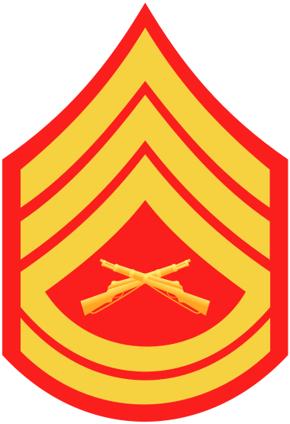
Private First Class  PFC  (E-2) |  | Master Sergeant  MSgt  (E-8) | 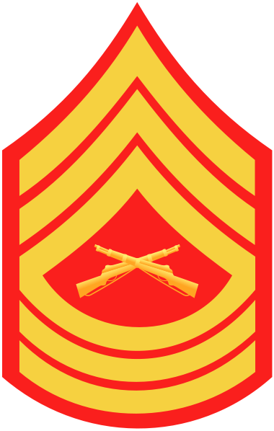
Lance Corporal  LCpl  (E-3) | 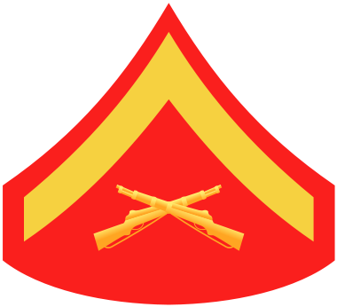 | First Sergeant  1stSgt  (E-8) | 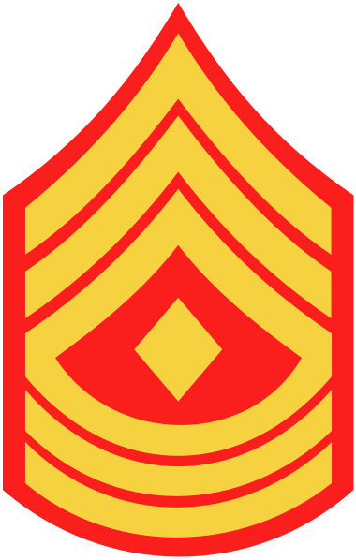
Corporal  Cpl  (E-4) | 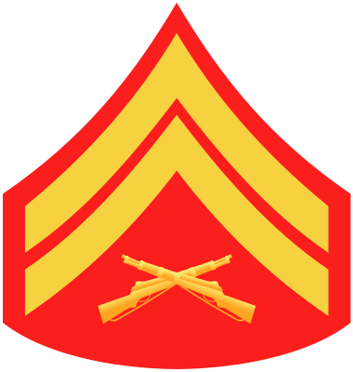 | Master Gunnery Sergeant  MGySgt  (E-9) | 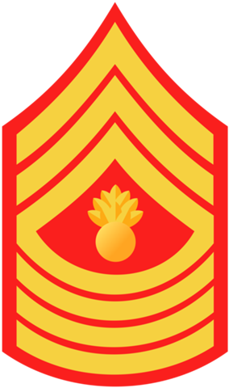
Sergeant  Sgt  (E-5) | 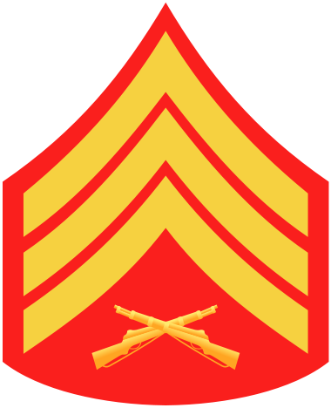 | Sergeant Major  SgtMaj  (E-9) | 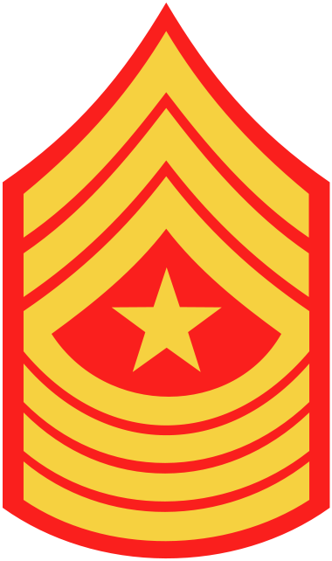
Staff Sergeant  SSgt  (E-6) | 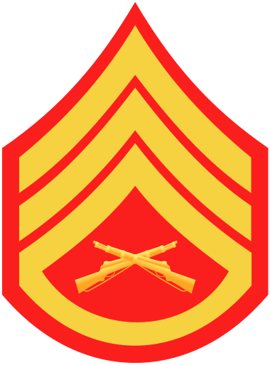 | Sergeant Major of the Corps  SgtMajMC  (E-9) | 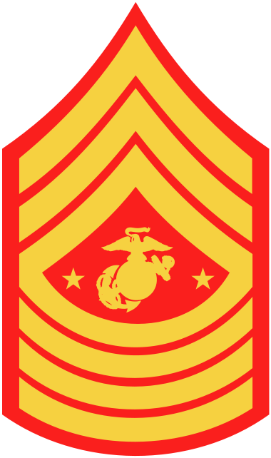

Marine Corps Officer/Warrant Officer Rank & Insignia

Title | Insignia | Title | Insignia
Second Lieutenant  O-1  (Gold Bar) |  | Warrant Officer  WO  (Gold Bar, 2 Scarlet Squares)
First Lieutenant  O-2  (Silver Bar) |  | Chief Warrant Officer 2  CWO2  (Gold Bar, 3 Scarlet Squares)
Captain  O-3  (2 Silver Bars) |  | Chief Warrant Officer 3  CWO3  (Silver Bar, 2 Scarlet Squares)
Major  O-4  (Gold Oak Leaf) |  | Chief Warrant Officer 4  CWO4  (Silver Bar, 3 Scarlet Squares)
Lieutenant Colonel  O-5  (Silver Oak Leaf) |  | Chief Warrant Officer 5  CWO5  (Silver Bar, 1 Scarlet Stripe)
Colonel  O-6  (Silver Full Bird Eagle) | 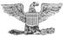
Brigadier General  O-7  (1 silver, 5-pointed star) |  | Marine Gunner  An Infantry Chief Warrant Officer  (CWO2-CWO5), wears the bursting bomb on the left collar and is referred to as a Marine Gunner. | 
Major General
O-8
(2 silver, 5-pointed star)
Lieutenant General
O-9
(3 silver, 5-pointed star)
General  O-10  (4 silver, 5-pointed star) | 

Navy Officer Rank & Insignia

Pay Grade | Rank | Abbreviation | Collar | Shoulder | Sleeve
O-1 | Ensign | ENS |  |  | 
O-2 | Lieutenant  Junior Grade | LTJG |  |  | 
O-3 | Lieutenant | LT |  |  | 
O-4 | Lieutenant  Commander | LCDR |  |  | 
O-5 | Commander | CDR |  |  | 
O-6 | Captain | CAPT |  |  | 
O-7 | Rear Admiral  (lower half) | RDML |  |  | 
O-8 | Rear Admiral  (upper half) | RADM |  |  | 
O-9 | Vice Admiral | VADM |  |  | 
O-10 | Admiral | ADM |  |  | 
O-11 | Fleet Admiral* | FADM |  |  | 

* The rank of Fleet Admiral has been reserved for war time use only. The last Fleet Admirals were in World War II. Fleet Admirals during that war were Chester W. Nimitz, William D. Leahy, Ernest J. King, and William F. Halsey.
Navy Warrant Officer Rank & Insignia

Pay Grade | Rank | Abbreviation | Collar | Shoulder | Sleeve
W-1* | Warrant Officer | WO1 |  |  | 
W-2 | Chief  Warrant Officer | CWO2 | 
W-3 | Chief  Warrant Officer | CWO3 |  |  | 
W-4 | Chief  Warrant Officer | CWO4 |  |  | 
W-5* | Chief  Warrant Officer | CWO5 |  |  | 
* The grade of Warrant Officer (W-1) is no longer in use. W-5 was established in the Navy in 2002.

Tips for inspection:
- Hydrate the night before.
- Make a head call before forming up.
- DO NOT LOCK YOUR KNEES.
- Wear appropriate undergarments. (Dark colors show through white pants)
- Keep your bearing.
- Shave immediately before inspection.
- Get a haircut the day before the inspection.
- Do not forget ID card in pocket.

